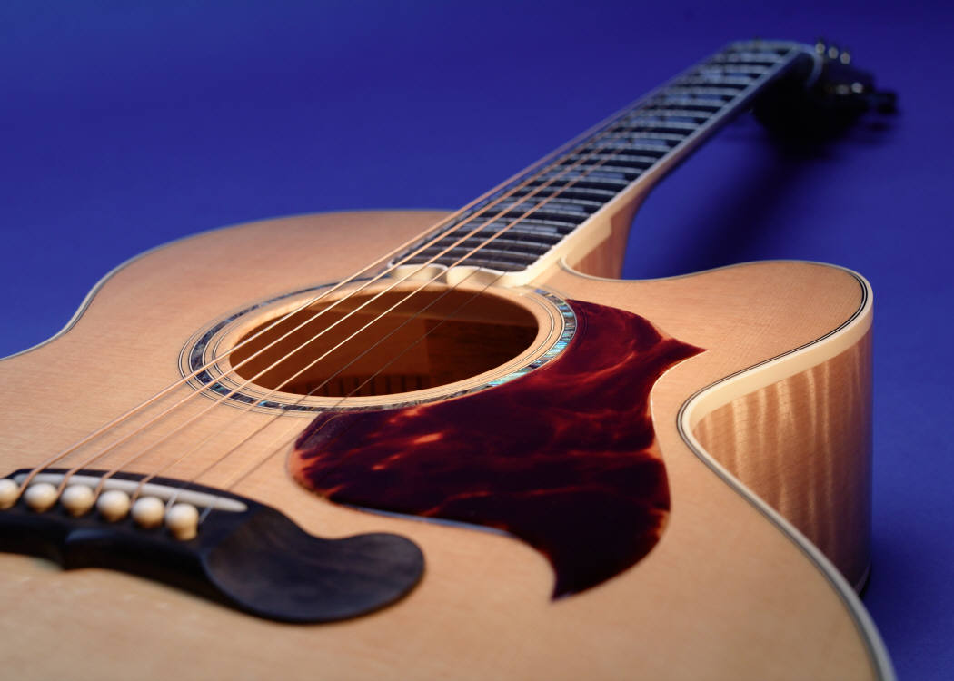

*Dan Graper*

*Acoustic guitar & vocals*

*Quality music for any occasion!*

***(484) 431-1028***

***dangrapermusic.com***

|  |  |  |  |  |  |
| --- | --- | --- | --- | --- | --- |
| 1 | Ain't no Sunshine | Bill Withers | 51 | Margaritaville | Jimmy Buffet |
| 2 | All My Loving | Beatles | 52 | Masquerade | George Benson |
| 3 | Always on my Mind | Willie Nelson | 53 | Me and Julio | Paul Simon |
| 4 | And so it goes | Billy Joel | 54 | Moondance | Van Morrison |
| 5 | Annie's Song | John Denver | 55 | More Today than Yesterday | Spiral Starecase |
| 6 | Any Major Dude | Steely Dan | 56 | Norwegian wood | Beatles |
| 7 | Baby I love your Way | Peter Frampton | 57 | Ordinary World | Duran Duran |
| 8 | Beginnings | Chicago | 58 | Over the Rainbow/Soul Sister | Israel K/Train |
| 9 | Behind Blue Eyes | The Who | 59 | Peaceful Easy Feeling | The Eagles |
| 10 | Black Magic Woman/Evil Ways | Carlos Santana | 60 | Play Me | Neil Diamond |
| 11 | Bohemian Rhapsody | Queen | 61 | Pride & Joy | S.R. Vaughn |
| 12 | Brandy | Looking Glass | 62 | Riders on the Storm | The Doors |
| 13 | Breakdown | Tom Petty | 63 | Rocketman | Elton John |
| 14 | Breezin' | George Benson | 64 | Route 66 | Nat King Cole |
| 15 | Call Me | Tony Hatch | 65 | Shower the People | James Taylor |
| 16 | Can't Help Falling in Love | Elvis | 66 | Solitary Man | Neil Diamond |
| 17 | Carefree Highway | Gordon Lightfoot | 67 | Space Oddity | David Bowie |
| 18 | Carolina in my Mind | James Taylor | 68 | Spooky | Classics IV |
| 19 | Classical Gas | Mason Williams | 69 | Stars and Stripes Forever | John P. Sousa |
| 20 | Come a little bit closer | Jay & Americans | 70 | Strawberry Fields Forever | Beatles |
| 21 | Country Roads | John Denver | 71 | Stray Cat Strut | Stray Cats |
| 22 | Daydream Believer | Monkees | 72 | Stuck in the Middle | Stealers Wheels |
| 23 | Dock of the Bay | Otis Redding | 73 | Sukiyaki | H. Nakamura |
| 24 | Doctor my Eyes | Jackson Browne | 74 | Sultans of Swing | Dire Straits |
| 25 | Driving my Life Away | Eddie Rabbit | 75 | Summer Breeze | Seals & Crofts |
| 26 | Feel like making love | Bad Company | 76 | Suspicious Minds | Elvis |
| 27 | Feeling Alright | Dave Mason | 77 | Sweet Caroline | James Taylor |
| 28 | Fields of Gold | Sting | 78 | Take it Easy | The Eagles |
| 29 | Fire and Rain | James Taylor | 79 | Take it to the Limit | Eagles |
| 30 | Folsom Prison Blues | Johnny Cash | 80 | The Letter | Boxtops |
| 31 | Fragile/Fields of Gold | Sting | 81 | The Shape of my Heart | Sting |
| 32 | Friend of the Devil | Grateful Dead | 82 | The Thrill is Gone | B.B. King |
| 33 | From the Beginning | ELP | 83 | The Way You Look Tonight | D. Fields |
| 34 | Grandpa was a Carpenter | John Prine | 84 | Things we Said Today | Beatles |
| 35 | Heart of Gold | Sting | 85 | Time in a Bottle | Jim Croce |
| 36 | Here comes the Sun | Beatles | 86 | Tin Man | America |
| 37 | Hotel California | The Eagles | 87 | Under the Boardwalk | Drifters |
| 38 | I Can See Clearly Now | Johnny Nash | 88 | Walk along the Brandywine | Dan Graper |
| 39 | I shot the Sheriff | Bob Marley | 89 | Wave | A.C. Jobim |
| 40 | I wouldn't want to be like you | Alan Parsons | 90 | We Just Disagree | Dave Mason |
| 41 | If you could read my mind | Gordon Lightfoot | 91 | We'll be Together Again | Carl T. Fisher |
| 42 | In My Life | Beatles | 92 | What Wonderful World | L. Armstrong |
| 43 | It's Probably Me | Sting | 93 | What you won't do for Love | Bobby Caldwell |
| 44 | Just the way you are | Billy Joel | 94 | Wild Horses | Rolling Stones |
| 45 | Kodachrome | Paul Simon | 95 | Wild World | Cat Stevens |
| 46 | Lay Lady Lay | Bob Dylan | 96 | Windy and Warm | Chet Atkins |
| 47 | Lighter than Air | Dan Graper | 97 | Witchita Lineman | Jimmy Webb |
| 48 | Listen to the Music | Doobie Brothers | 98 | You Can't Do That | Beatles |
| 49 | Little Wing | Jimi Hendrix | 99 | You Make me Feel so Young | Frank Sinatra |
| 50 | Lovely Day | Bill Withers | 100 | You've got to Hide your Love away | Beatles |